Faculty of Computing and Informatics TPT2201 Industrial Training Student’s Weekly Logbook

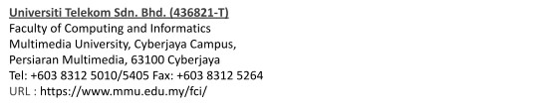

|  |  |  |
| --- | --- | --- |
| Name of the Student | | Nik Ahmad Uzair bin Nik Ahmad Faisal |
| ID of the Student | | 1201200657 |
| Name of the Company | | Grab |
| Period of Training | | 3 Months |
| Name of the Company Supervisor | | Xiuying Qi |
| Name of the Faculty Supervisor | | Mr. Tong Gee Kok |
| Week Number/Report Period | | Week 11 |
| Brief Description of Tasks done during the Week  (9/23-9/27) | | * Attended bowling sessions with interns. * Continued with the project (1). * Got assigned to new project (2). * Began onboarding for the new internal tools project, reviewing all related documentation and requirements. |
|  |  |
|  |  | |



|  |  |
| --- | --- |
| Reflections (Problems encountered if any, Reasons for non-completion of planned tasks if any, Lessons learned, Tasks planned for the next week etc.) | **Blockers:**   * NIL   **Next Week Plan:**   * Continue with project (1) and project (2). |
| Remarks from Company Supervisor (if any) |  |
| Signature of Company Supervisor with company stamp |  |

